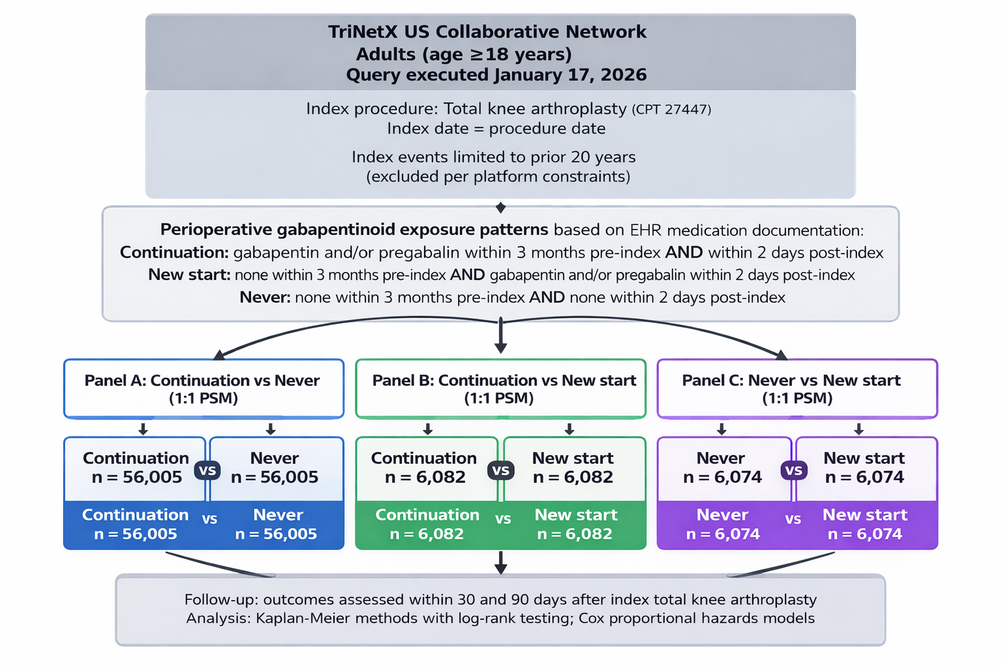
Fig 3. Cohort selection and propensity score matching for adults (age ≥18 years) undergoing total knee arthroplasty (CPT 27447) in the TriNetX US Collaborative Network (query executed January 17, 2026). Perioperative gabapentinoid exposure was defined using EHR medication documentation and categorized as: Continuation (gabapentin and/or pregabalin within 3 months pre-index and again within 2 days post-index), New start (none within 3 months pre-index and gabapentin and/or pregabalin within 2 days post-index), and Never (none within 3 months pre-index and none within 2 days post-index). Separate 1:1 propensity score matching was performed for three pairwise comparisons: Panel A Continuation vs Never (n=126,941 per cohort), Panel B Continuation vs New start (n=6,227 per cohort), and Panel C Never vs New start (n=6,221 per cohort). Outcomes were assessed within 30 and 90 days after the index procedure, beginning 1 day post-index.

